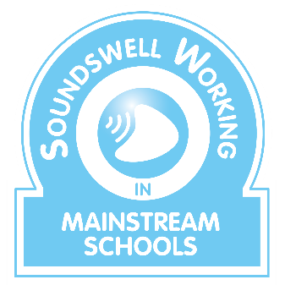

Soundswell Working in Mainstream Schools –
a training course for therapists

Soundswell therapist Kate recently delivered a SWIMS course to a London group of new and recently qualified therapists.
All Soundswell training courses clearly identify anticipated learning outcomes and participants rate these both before and after the course.
For SWIMS, the London group reported that they had enjoyed a ‘brilliant’ day!
Just as importantly, the learning outcomes data showed that significant gains had been made.

Learning outcomes |  | % gain
1 | Understand the national context in the field of SLCN | 61.5%
2 | Understand the cycle of communication | 91.3%
3 | Your knowledge of methods and tools useful when screening for and identifying SLCN | 53.5%
4 | To consider the range of interventions that can be used … | 63%
5 | Develop a wider understanding of available resources and ways to use them flexibly to support SLCN at all levels of the pyramid of intervention | 83%
6 | Consider how to measure impact – how and why is this important? | 95%

One would expect a reasonable level of knowledge and experience in terms of outcomes 3 and 4 and this is evidenced by fewer % gains. Conversely, outcomes 2, 5 and 6 are areas where NQTs or returners need greater exposure to ‘doing the job’ and this is exactly the practical support that this course provides.
“Very informative and a wide range of examples for interventions and resources to use in everyday therapy. Given me a confidence to advocate the importance of universal strategies at school as most of my schools are very specialist and referral focused”
resources I’m leaving with. Thank you!”
“I really enjoyed it! The presentation was very informative and interactive. I love all the

