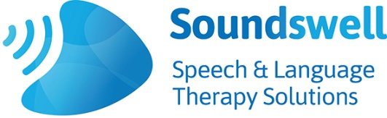 | Speech and Language Therapy Provision summer term 2020  Further information

Training | Soundswell therapists have been delivering training via ‘Zoom’ during school closures.  We now have a wide range of packages that have been adapted to this method of delivery, and we can successfully deliver interactive sessions to 40 + people at once.  Feedback about our remote training has been fantastic and we will continue to offer these sessions remotely as an alternative to the traditional on site method.  Our existing range of training courses continue to be available for delivery in schools and settings, please see ‘Soundswell Training Travels’ flier or speak to us for a more bespoke package.
Booster & Intervention groups | Choose from a range of speech and language intervention groups including :-  - Attention and Listening  - Vocabulary development  - Sound awareness for children with poor speech  - Phonological awareness  - Understanding language  - Expressive language  - Developing narrative skills  - Using colour coding to support language and literacy  - Wellcomm Speech & Language Toolkit language groups  These intervention groups can target pupils already identified as having SLCN, and will be designed to be delivered at a level appropriate to the children’s needs  We can also provide ‘booster’ groups to accelerate language development for those at increased risk of falling behind following the recent school closures.
Individual therapy | One-to- one therapy sessions on-site can still be delivered for the majority children who need this specialist level of support.  Sessions can also be delivered remotely into the children’s homes which is a way to effectively involve parents in the therapy process

